Writing an AERA Proposal
By Najia Sabir, Justin Whiting, and Verily Tan
Indiana University
June 27, 2016
See Google Docs: https://docs.google.com/document/d/1zyqdewUd6Xpjb6q_YMS-9uV3hWWVOdPVyMfm5DE7ZuA/
General Info
Side note: If you are submitting a research project for presentation you will need IRB approval. If you don’t have it, be prepared to justify why!
- Don’t wait until the night before. This is not a 1-page proposal. Also log into the AERA submission system days before you start writing. This will help you structure sections on a word processor.
  - You can revise and upload a newer version of the proposal before the deadline.
- Look over some example proposals. Ask your peers or visit the AERA main page (http://www.aera.net/About-AERA/Member-Constituents/Graduate-Student-Council/Proposal-Examples-V2)
- Figure out what kind of presentation (Paper, Poster, or Roundtable) you want to do before you start writing and tailor your proposal.
  - If you select the option of submitting a Paper. Think about also letting your proposal be considered for a Poster or Roundtable that way at least you have a chance at presenting something.
  - You can find more info on the presentation formats here: http://convention2.allacademic.com/one/aera/aera10/files/paper_submission_descriptions.html
  - Don’t be stuck on only wanting to do a Paper presentation. Posters and Roundtables can be more productive, especially for students as they give you a chance to interact more with audience.
  - Also figure out what division and section, or SIG you want to send it to. That way you can tailor the proposal to better align with their call.
  - If you are confused about which section/SIG to submit to, read over their Call for Proposals (http://www.aera.net/Portals/38/docs/Annual_Meeting/2017%20Annual%20Meeting/2017_CallforSubmissions.pdf?ver=2016-06-16-120020-207). You can find individual SIG/Section calls in the submission portal too!
    - Link to Division descriptions: http://www.aera.net/About-AERA/Member-Constituents/Divisions/Division-Descriptions
    - Link to SIG descriptions: http://www.aera.net/About-AERA/Member-Constituents/SIGs
- Remember that AERA likes completed studies. Write in the past or present tense. Also you should present some data...even if they are preliminary findings.
  - Methods section is particularly important - i.e., research question, data sources, analysis methods
  - Preliminary findings may suffice. If accepted the expectation will be to report more detailed findings and insights.
- Review all of the detailed guidelines. Did you include all the parts that you needed to? If you are missing an one element such as a discussion it hurts your chances greatly.
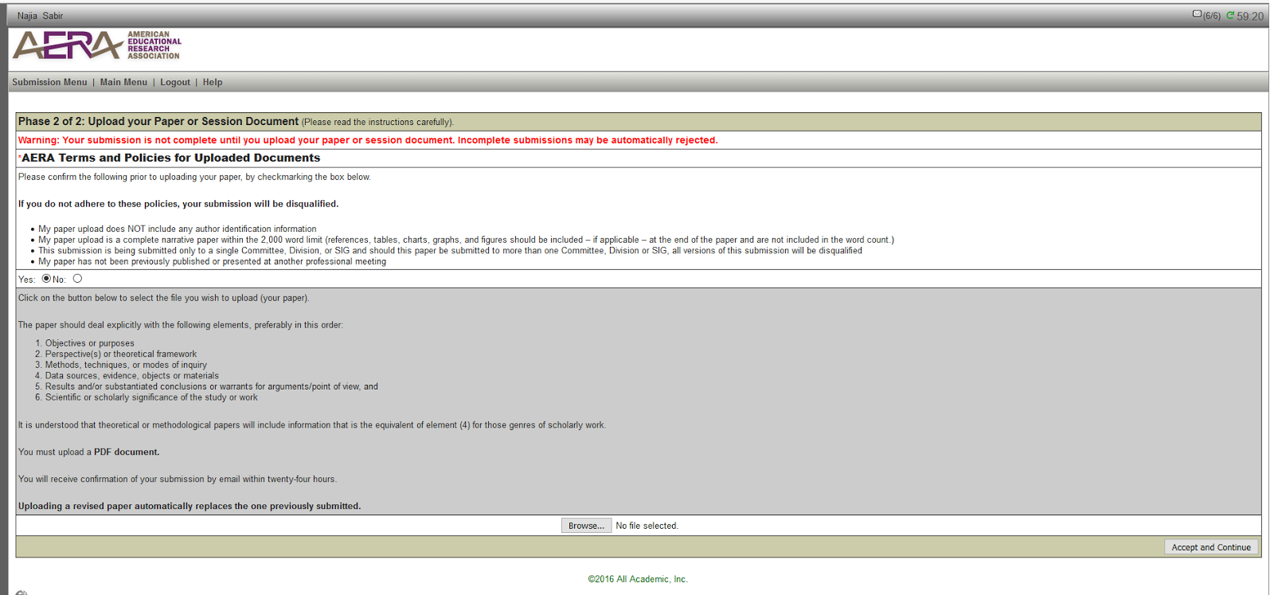
- Make sure you meet the word count limit criteria!
  - Title (15 words)
  - Abstract (120 words)
  - Paper (no more than 2,000 words)
  - You might want to include the actual word count for the reviewers’ convenience.
- You do not have to incorporate the annual theme into your paper. You shouldn’t try to change your research or presentation just to fit the theme, but it will help if your research is in line with others. Again, an important part of this is submitting to the correct SIG with similar research.
- Omit author identification from your proposal. That includes your writing, in text citations and references.
  - According to APA, in-text cite would be (Author, YEAR). References: Author. (YEAR).
  - You may have to change the order of authors on your proposal. AERA only allows a certain number of entries per person.
- Make sure your proposal follows APA guidelines, is spell checked and grammar proofed. Duh, right? But when you are pulling an all-nighter to write an AERA you will be surprised what slipped through the cracks. Get someone to proof-read for you.
- Work smart, not hard. If you have preexisting work, you can adapt it and build your AERA proposal off that.
Specific to the Proposal
- Make your proposal stand out from the start! The abstract and introduction are very important. Remember most reviewers end up reading 10 or more proposals, make yours memorable.
- Be descriptive (yet concise) in your methods section. Let your reader know what you did during your study! A good test for this is calling up a parent/sibling and having them read then explain the section to you. If they can accurately describe your methods after reading the section, then you win!
- Explain why your research is important. Yes we know it furthers the knowledge base...but really, why should someone care. What is the impetus?
- Your research doesn’t need to be perfect. Do your best and get feedback, but don’t get stuck on trying to change the world or have the perfect paper. Remember that you will have more than one reviewer, so don’t be discouraged! Proposal scores are averaged out between 3+ reviewers, so you get feedback from different perspectives too!

